Multispectral Data Extraction in QGIS

Taylor Nelsen

March 20, 2019

*This standard operating procedure (SOP) was written based on QGIS Version 2.18.26. To download QGIS visit:* [*https://qgis.org/en/site/forusers/download.html*](https://qgis.org/en/site/forusers/download.html)

# Introduction

This SOP outlines methods to extract quantitative data from areas of interest in multispectral images. The “Low Throughput Data” section outlines how to manually create a shapefile and extract multispectral data based on that shapefile. This method needs to be understood in order to use the “High Throughput Data” methods. The low throughput data method is best used when there are few plots, they are of irregular areas, and/or they are not regularly distributed. The “High Throughput Data” section outlines a more automated process for shapefile creation and multispectral data extraction. It is best used when there are large numbers of uniform plots (uniform in size, shape, and distribution). Part 0 includes steps that are common to both methods.

# Part 0: Setup

1. Open QGIS Desktop 2.18.26
2. Create a new project: “Project” > “New”
3. Name and save your project: “Project” > “Save As…”
4. Add a clearly captured raster image (most commonly .tif format) of your trial or area of interest (see image below): “Layer” > “Add Layer” > “Add Raster Layer…”

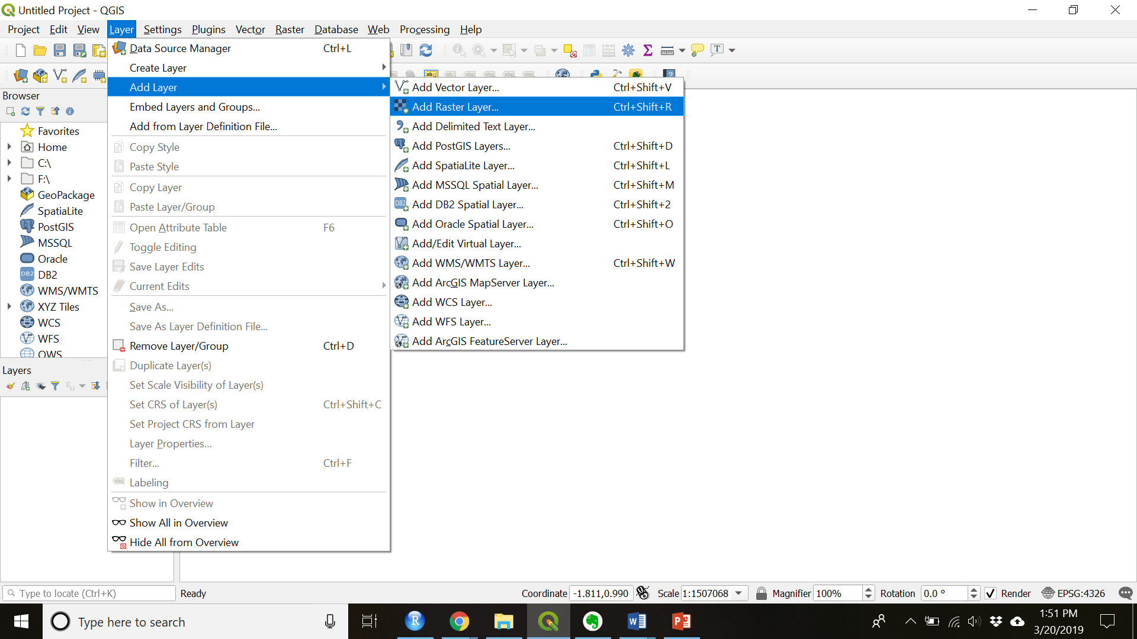

5. Navigate to and choose your image file.

# Part I: Low Throughput Data Method

## Create the shapefile

1. Create a new shapefile layer: “Layer” > “Create Layer” > “New Shapefile Layer…”
2. Set the properties of your shapefile:
   1. Select “Polygon” for the geometry type

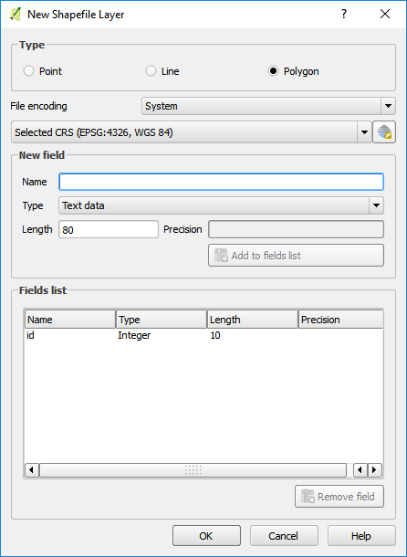

* 1. Click “OK”
  2. When prompted save the file to a folder on your computer
  3. Set the coordinate system to match your multispectral image (see image below)

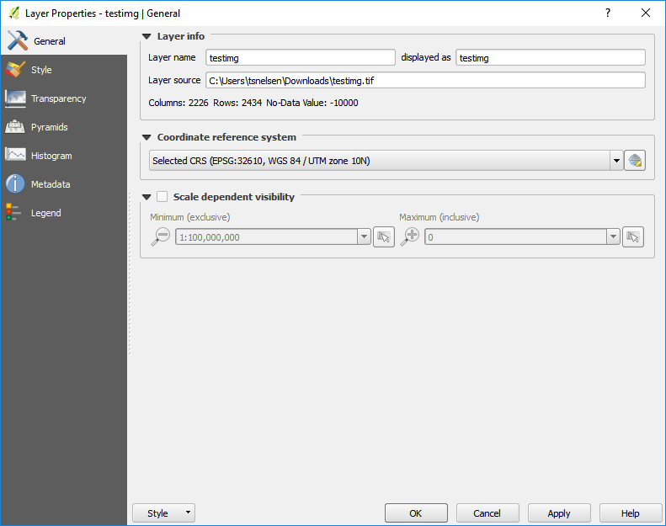

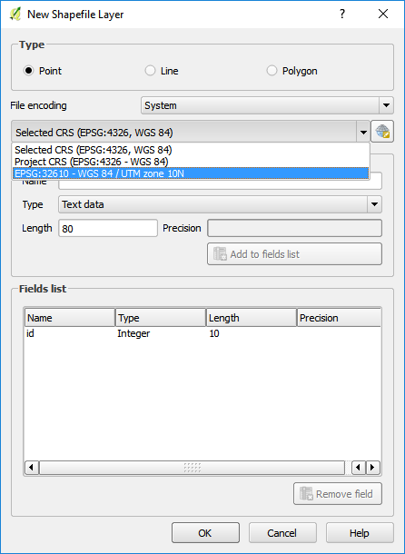

1. Click “OK”
2. Edit the shapefile:
   1. Make sure the shapefile you created is highlighted in the layers panel.
   2. Toggle editing on by right clicking then selecting the yellow pencil (see image below)

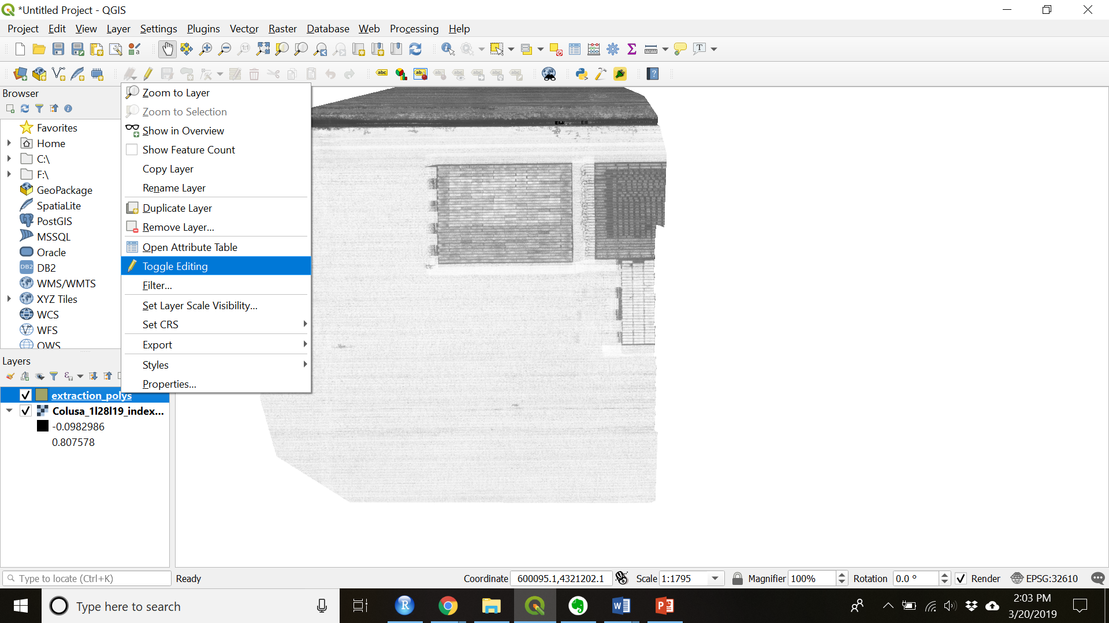

* 1. Add a feature by clicking the “Add Polygon Feature” button (see image below)

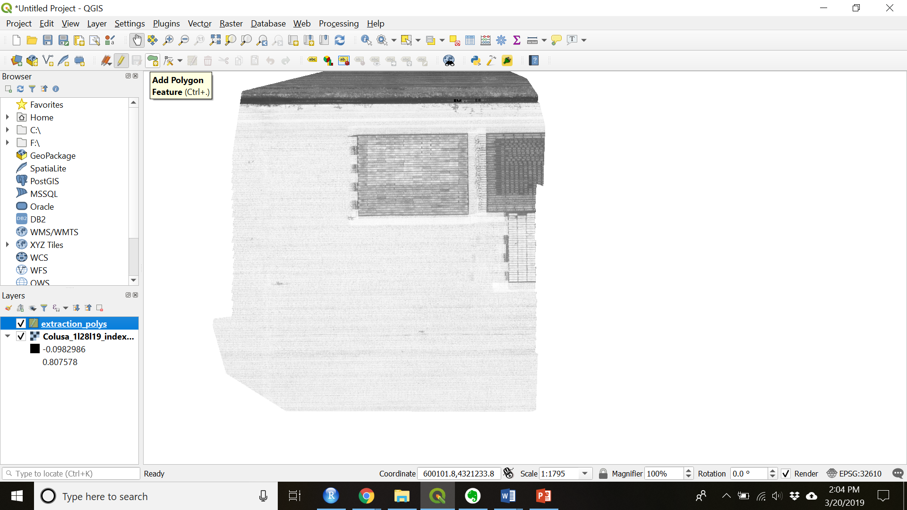

* 1. Using your courser click draw the outline of your area of interest. Each left click creates a point and a right click closes the polygon.
  2. Set the ID of each point as a consecutive integer.
  3. Repeat for as many features as you desire for that image.

1. End your edit session by clicking the “Toggle editing” button again.
2. Save your edits when prompted.
3. Add plot level metadata into the attribute table.
   1. Toggle editing on for the shapefile you just created
   2. Open the attribute table by right clicking the highlighted shapefile layer and choosing “Open Attribute Table” (see Figure 6).

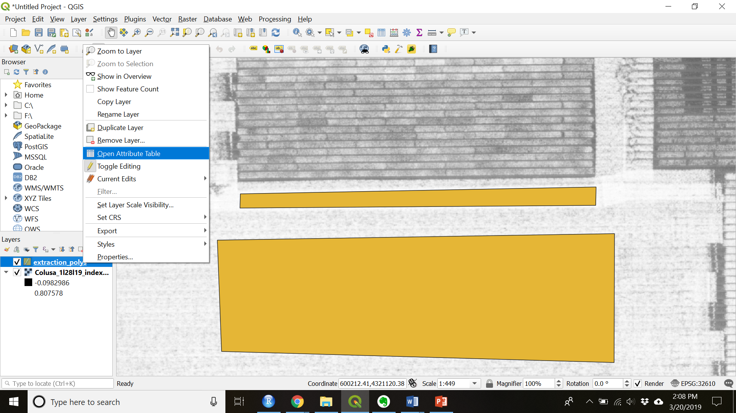

* 1. Ctrl + W to create a new field
  2. Name the new field appropriately and populate with metadata (see image below)
     1. Make sure the “Type” and “Length” fields are filled out appropriately

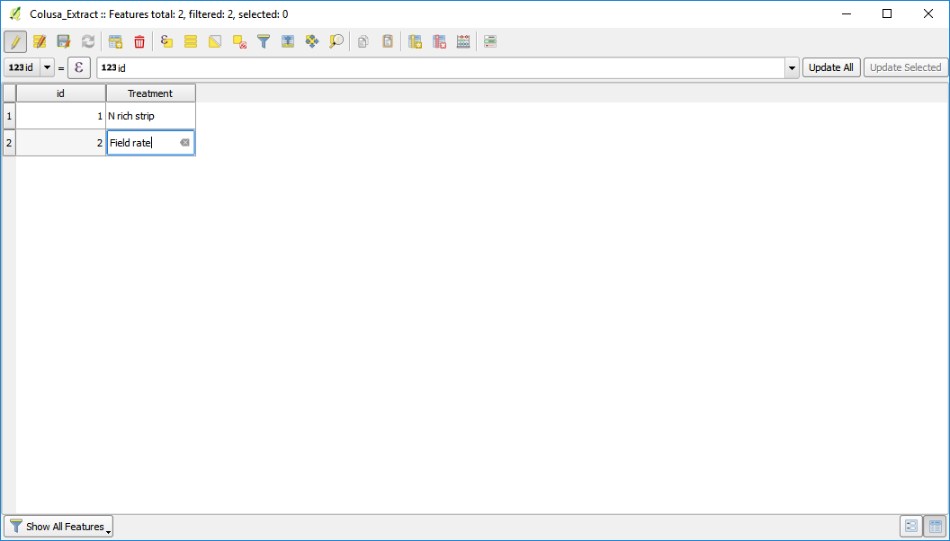

## Zonal Statistics

1. Check that the “Zonal Statistics” plugin is installed and active
   1. Navigate to: “Plugins” > “Manage and Install Plugins…”
   2. Search for the “Zonal statistics plugin” and install if not already installed
2. Find “Zonal Statistics” under “Raster”
3. Open “Zonal Statistics” and then fill in and run (see image below)
4. Choose the raster layers band you wish to extract.
5. Choose the shapefile layer that overlays it.
6. Set the pre-fix to the band you are extracting (in order to keep track of your data)
7. Check whichever boxes of statistics you want to calculate.
8. Click “OK” to run the algorithm

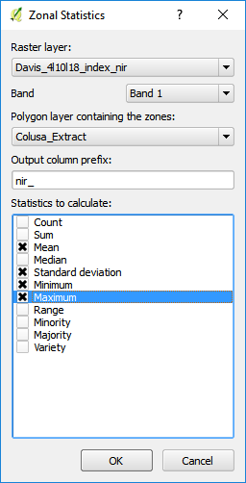

1. Look at the values you extracted by right clicking on your shapefile layer and navigating to “Open Attribute Table”.
2. You attribute table should contain values for each of the polygons you created and each statistic you checked in the Zonal Statistics window (see below).

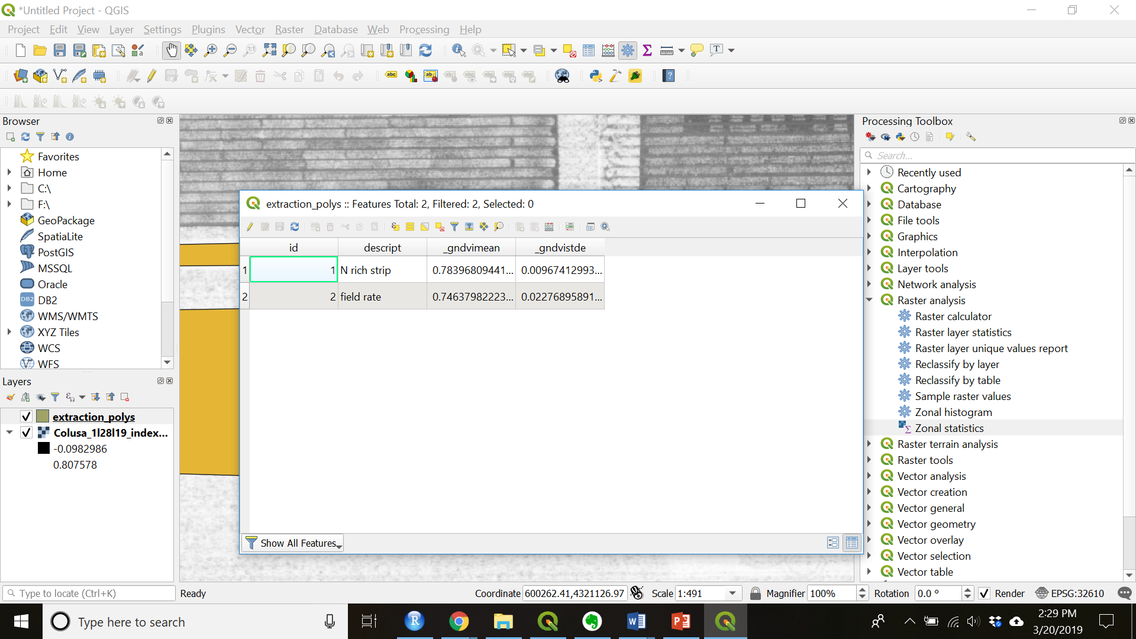

1. The make sure you have toggled editing off and saved the shapefile.
2. Export the extracted data as a csv file (see image below)
   1. Right click the highlighted shapefile
   2. Navigate to “Save As…”
   3. Change the Format to “Comma Separate Value [CSV]”
   4. Name and save the file in a folder on your computer
   5. Check that the CRS is correct
   6. All other defaults are fine to leave
   7. Press “OK” when everything is set to output and save the CSV

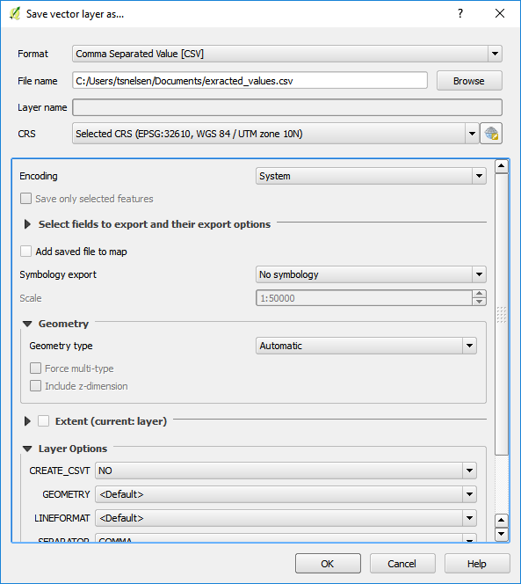

1. Close QGIS.

# Part II: High Throughput Data Method

## Create the shapefile

1. Check the projection of your shapefile, if it is not in latitude and longitude (EPSG: 4326) then save it so that the projection is in latitude and longitude.
   1. Right click the raster layer and choose “Save As…”
   2. Change the CRS to EPSG:4326 – WGS 84 (see image below)

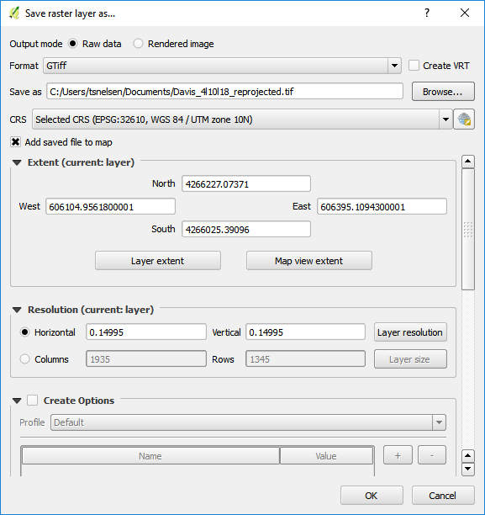

* 1. Click “OK” to save the image

1. Create a shapefile to set the origin points of your trial. This is used to calculate the angle the field is at the distance the plots are from each other.
   1. Create a new layer by choosing: “Layer” > “Create New Layer” > “New Shapefile Layer…”
   2. Name and save the file to a folder on your computer
   3. Choose “Point” as the geometry
   4. Make sure the CRS is ESPG: 4326 – WGS 84
   5. Click “OK” to create the blank shapefile
2. Set the origin points.
   1. Toggle editing on the shapefile just created.
   2. Choose the “Add Point Feature” tool (see figure below)

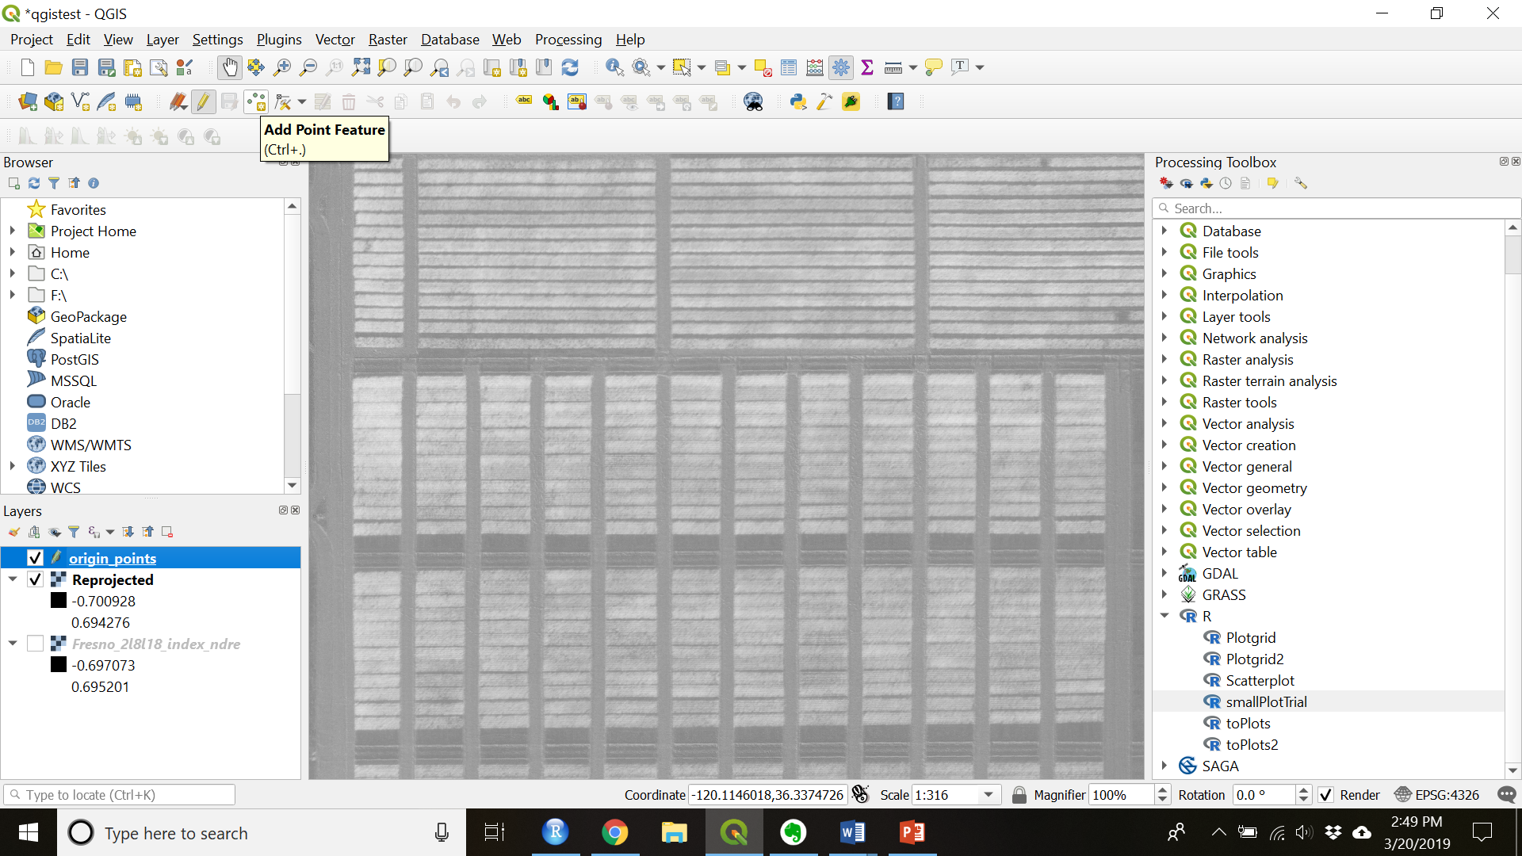

* 1. Add 3 points as follows: plot 101 (the bottom left corner of your trial) should have id = 1, the bottom right corner should have id = 2, the top left corner should have id = 3
     1. Do not include fill rows or data you do not want to extract
  2. Toggle editing off to save

1. Close QGIS
2. Open R Studio
3. Open “helper_code.R”

This code will load the packages and functions you need to use to create shapefiles.

1. Open QGIS and load the shapefiles just created to make sure they align properly with the plots
   1. Navigate to “Layer” > “Add Layer” > “Add Vector Layer…”
   2. Browse to the shapefiles with the “_extract.shp” ending and select them.
   3. Press “Open” to open the layers into your project

## Adjust the Shapefile

*In some cases the shapefile will need to be adjusted to make sure that it is accurately within all the plots.*

1. Toggle editing on for the shapefile.
2. Make sure the shapefile is highlighted.
3. Select all (or the subset that you wish to adjust) by choosing the “Select Features by area of single click” (see image below) and drawing a rectangle around the features you want to adjust.

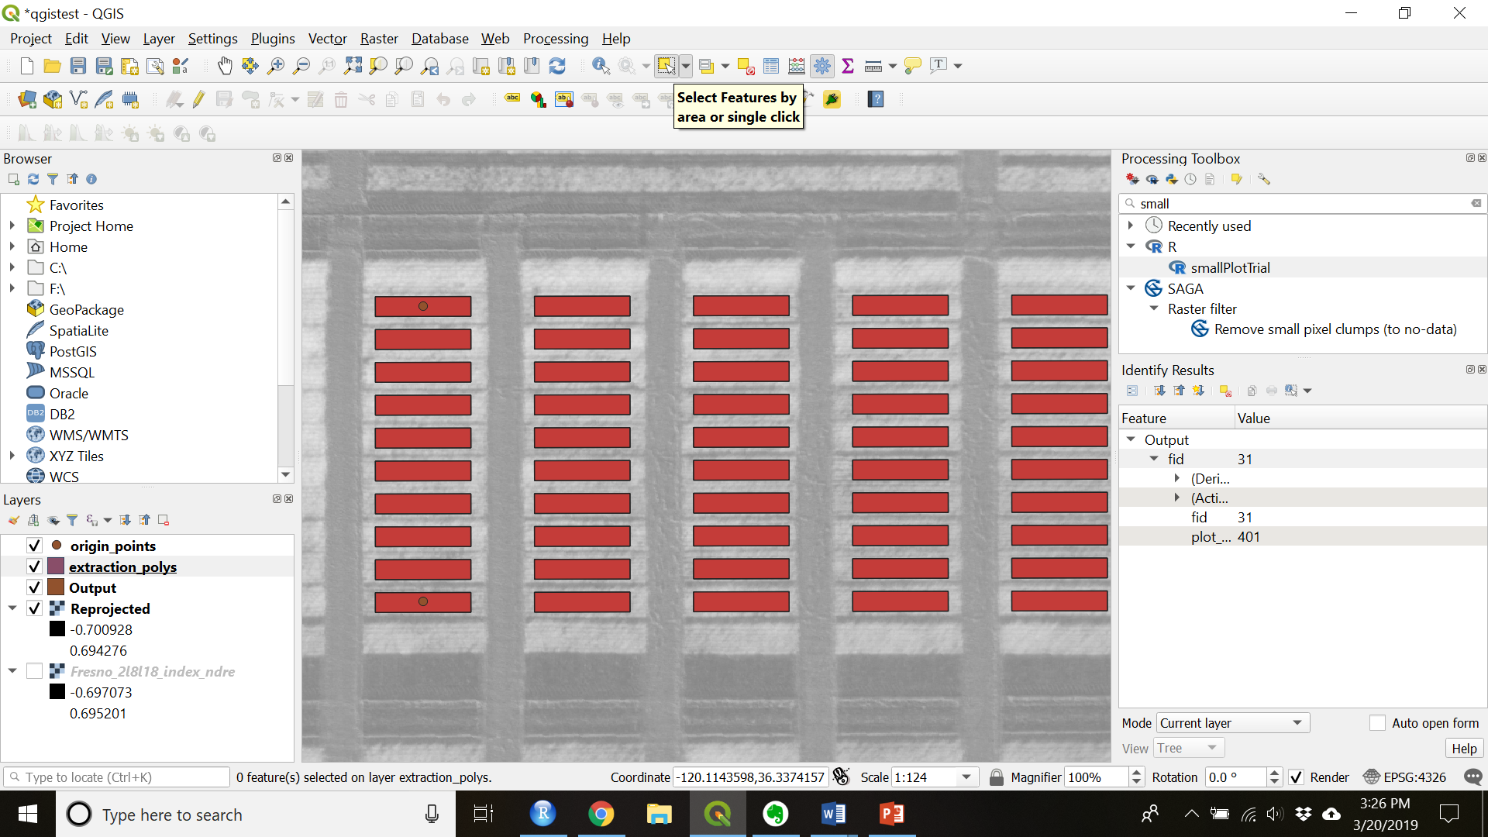

Figure 14. Select features tool

1. Make sure the “Advanced Digitizing Toolbar” is visible.
   1. If it is not navigate to “View” > “Toolbars” and check “Advanced Digitizing Toolbar”
2. Move or rotate using the appropriate tools (see images below).

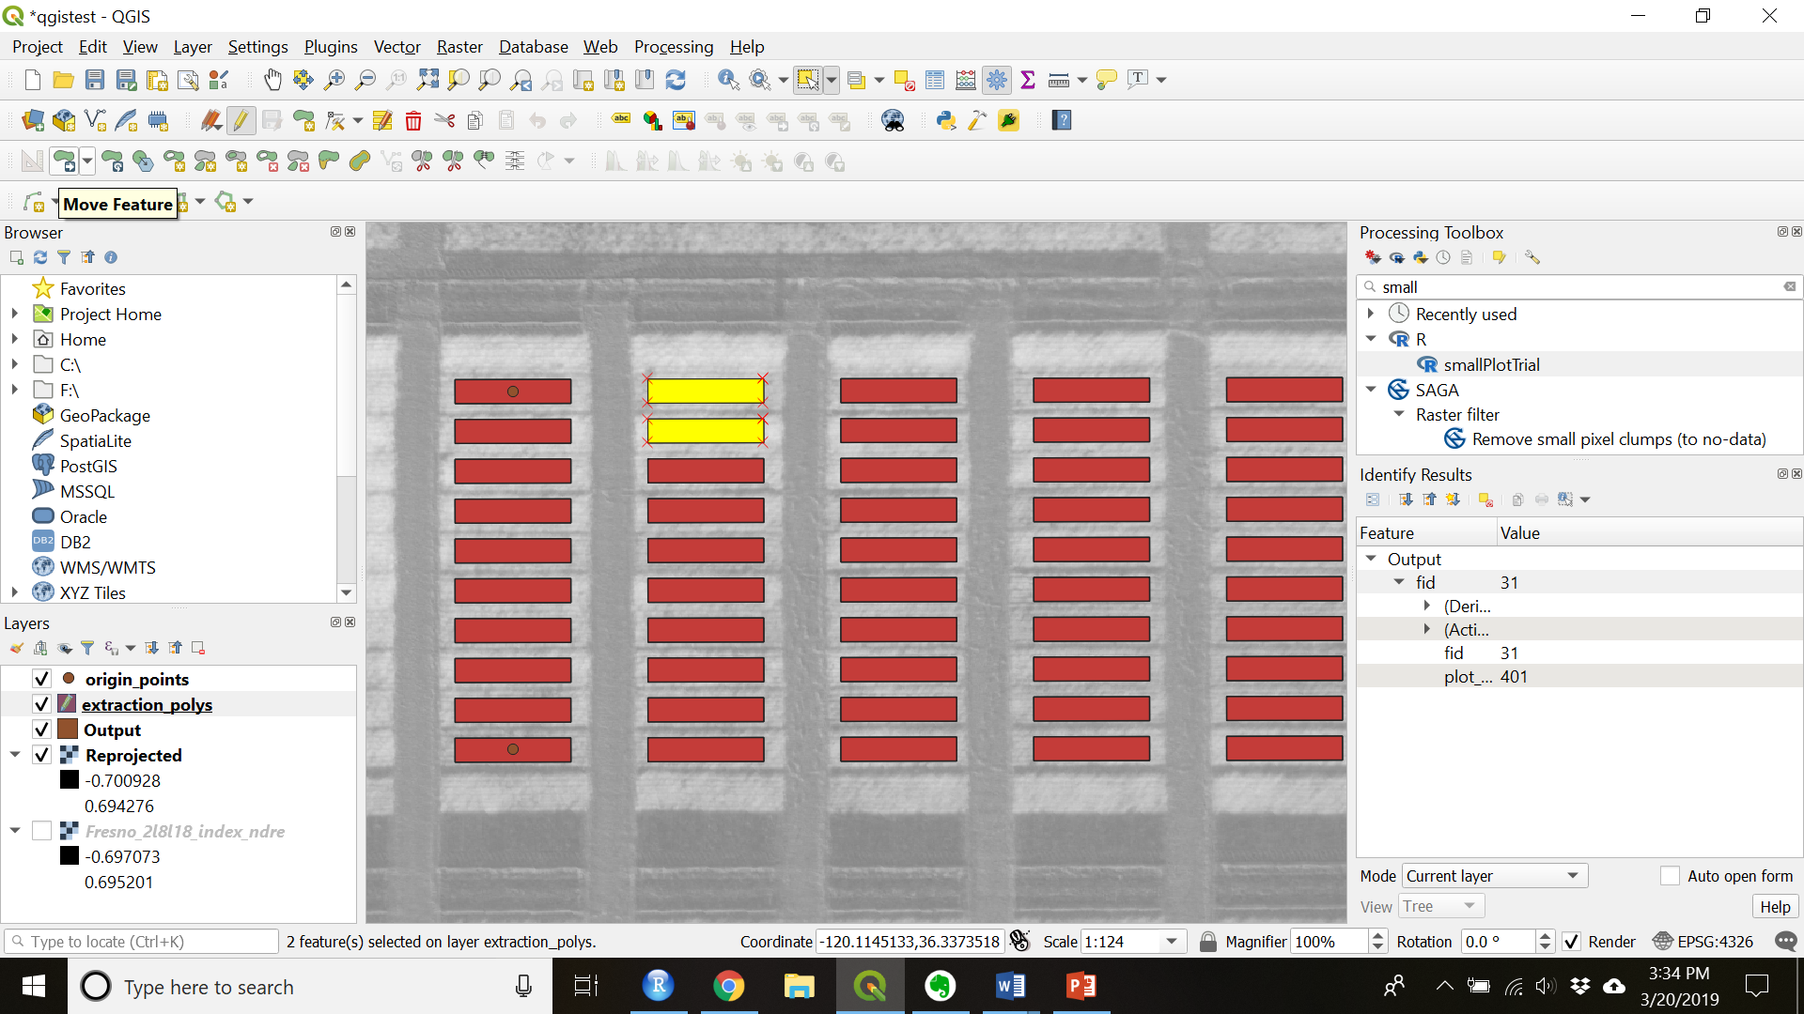

Figure 15. Move Features(s)

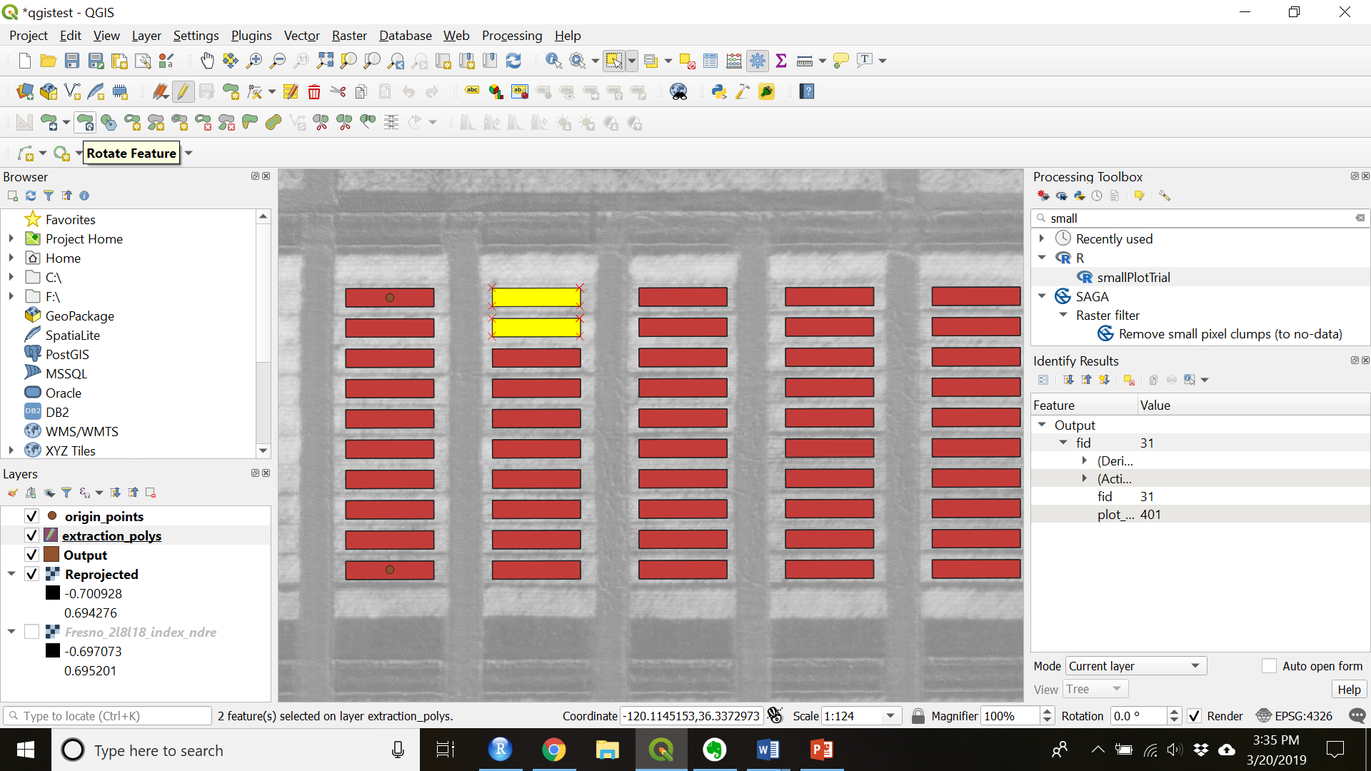

Figure 16. Rotate Features(s)

1. Toggle editing off to save.

# Merge shapefiles

1. Make sure each different trial, block, etc is labeled with unique identifiers in the attribute table (they should if you created them with the helper_code.R)
   1. If not create a new field in the attribute table and replace all the cells with an identifier for that field using: replace( 'NULL','NULL','mystring' )
2. To merge the shapefile layers navigate to: “Vector” > “Data Management Tools” > “Merge vector layers” (see image below)

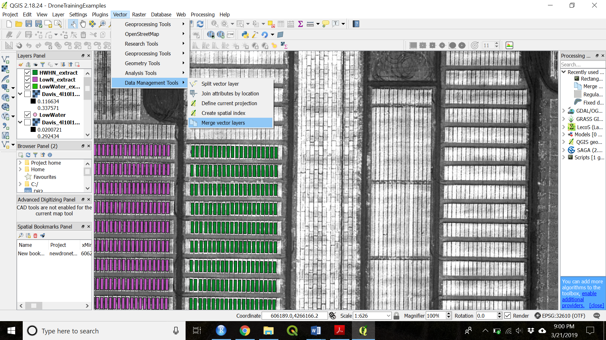

1. Select the layers you want to merge

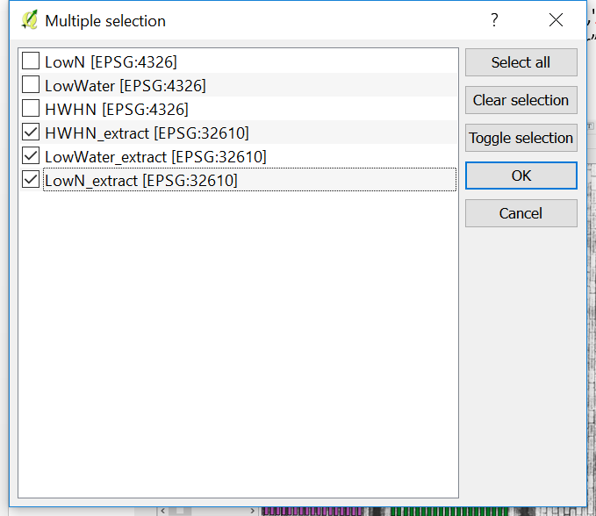

1. Click “OK”
2. Name and save the new file in a folder on your computer

# Extracting over several dates

*If you have images from several different dates you have 2 options: 1) You can create a new shapefile and extract data for each date. 2) You can georeference your images so that they overlay each other and then use the same shapefile.*

*In order to georeference you must have static, identifiable objects or characteristics that you can clearly see in the images.*

# Georeferencing:

**With ground control points in Pix4D:**

<https://support.pix4d.com/hc/en-us/articles/202558699-Using-GCPs#gsc.tab=0>

**With tie points in QGIS:**

1. Open QGIS
2. Project > New
3. Add a raster layer of your base image.

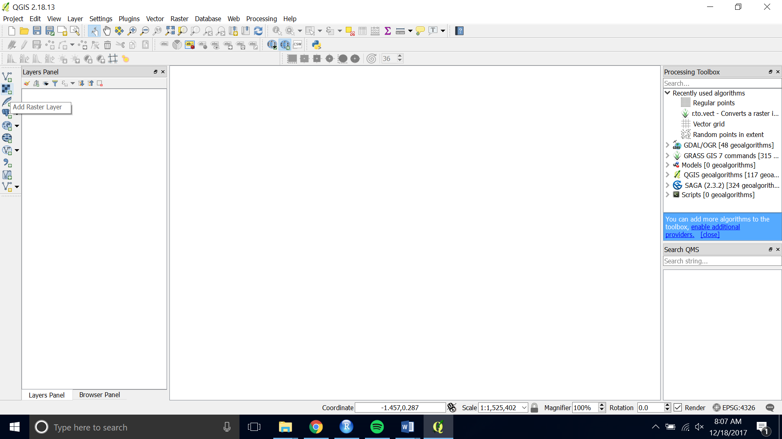

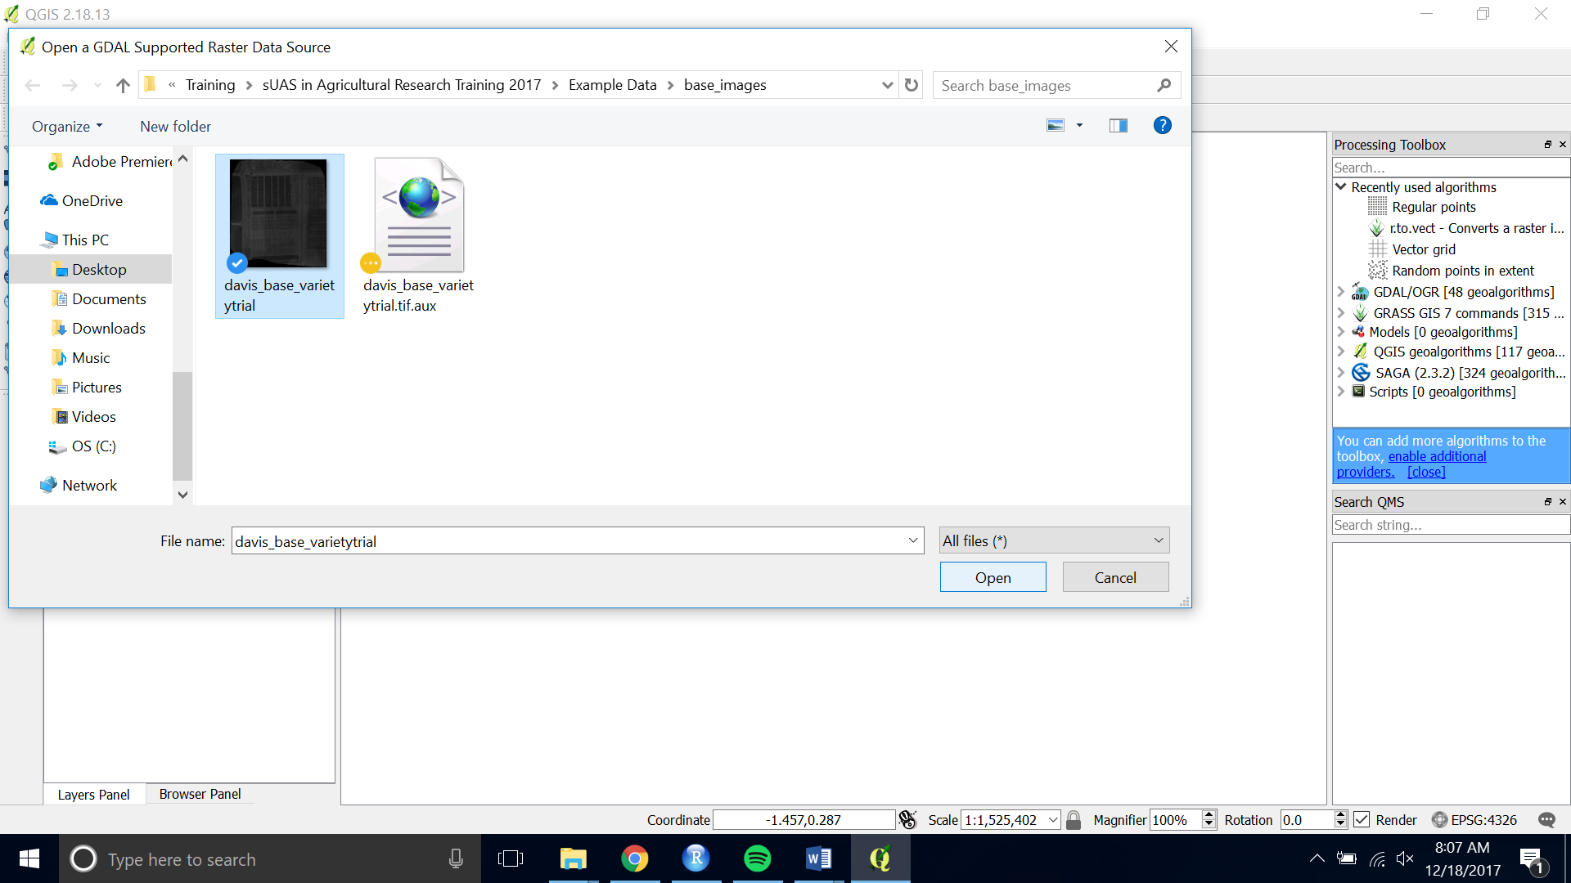

1. Open the Georeferencer.

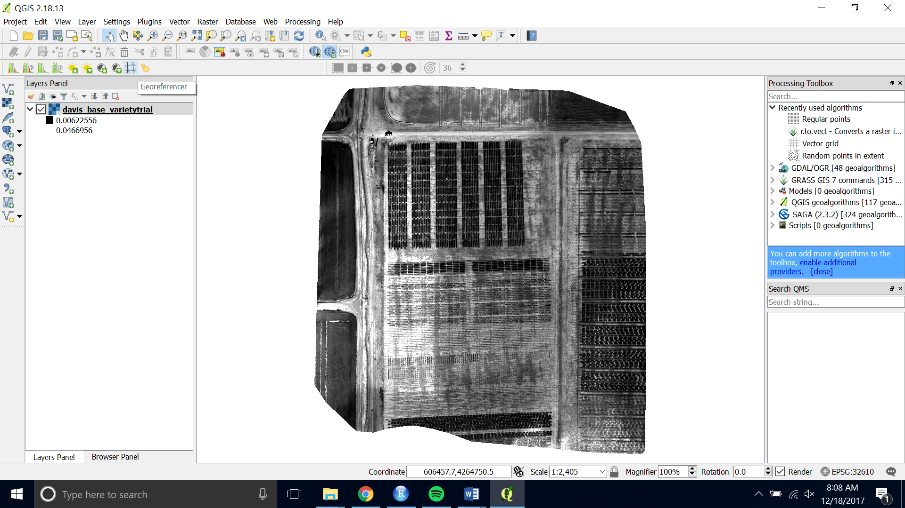

1. Choose the raster you want to Georeference by opening the raster and navigating to the image you want to georeference.

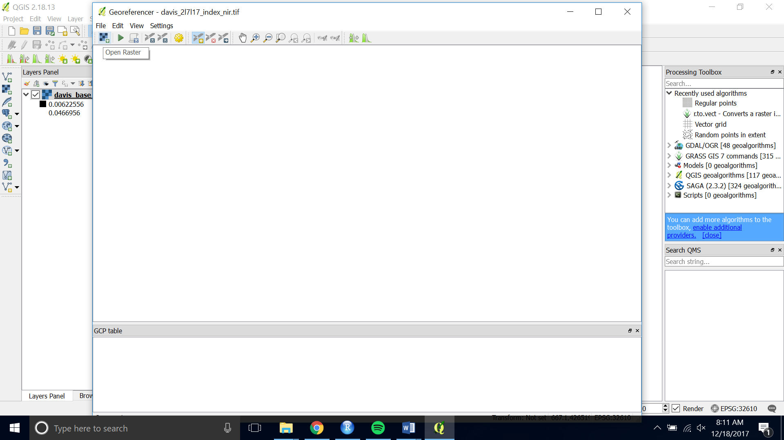

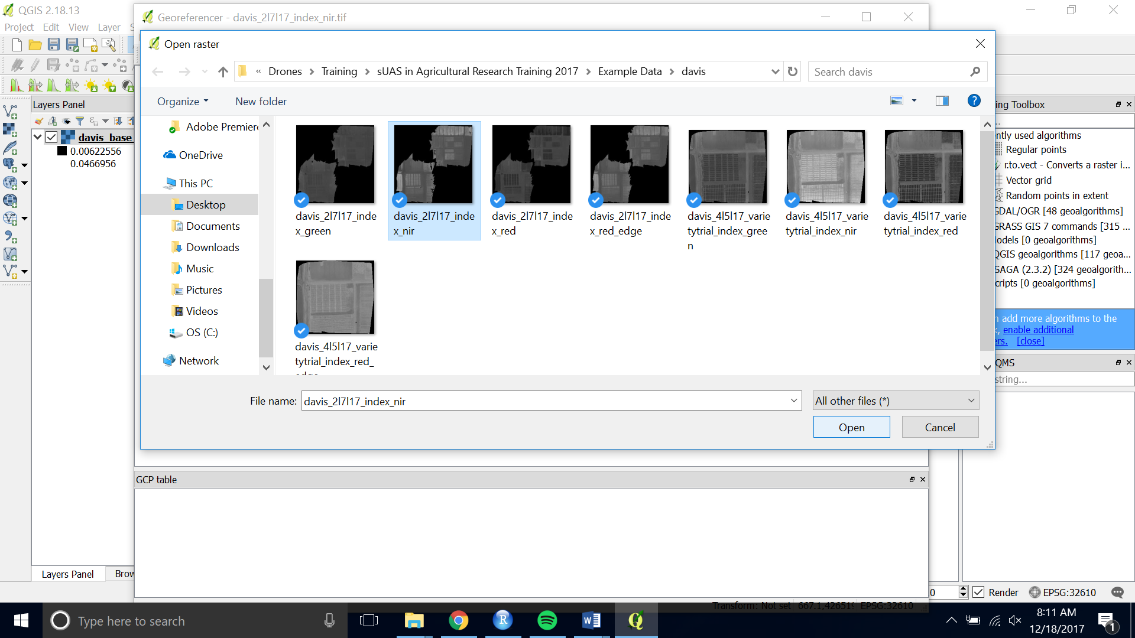

1. Zoom and pan to a place in the image that will be there for the entirety of the season or the time period when you are planning to fly. Using the center of a plot works well.

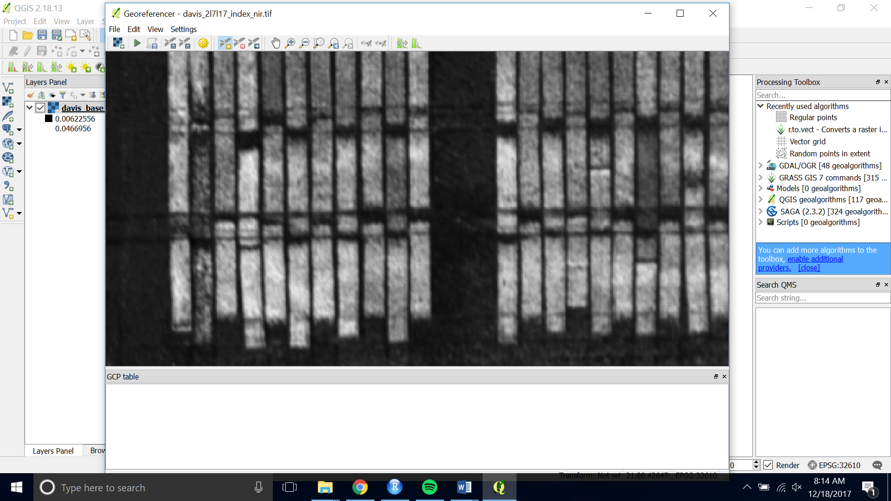

1. Choose the yellow “Add Point” button at the top of the interface.

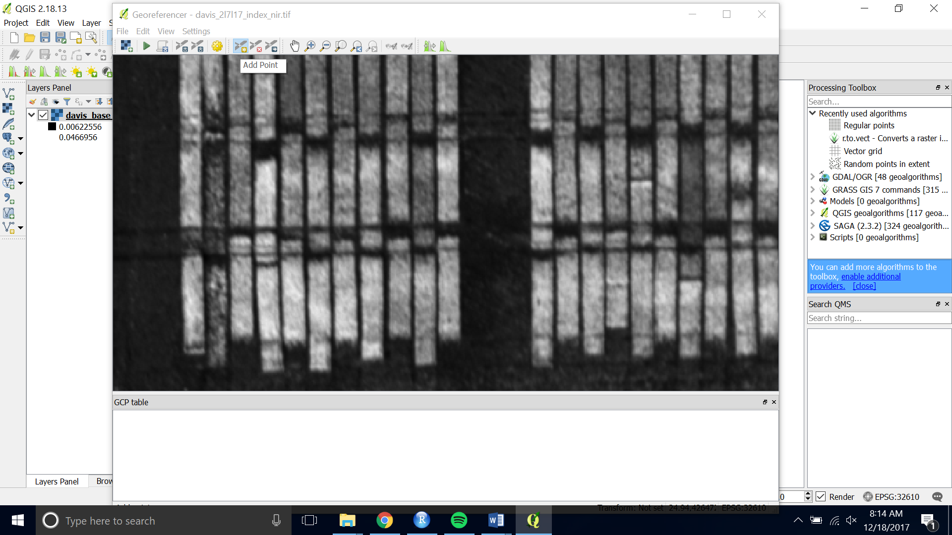

1. Click on the tie point you have chosen. Then choose “From Map Canvas”

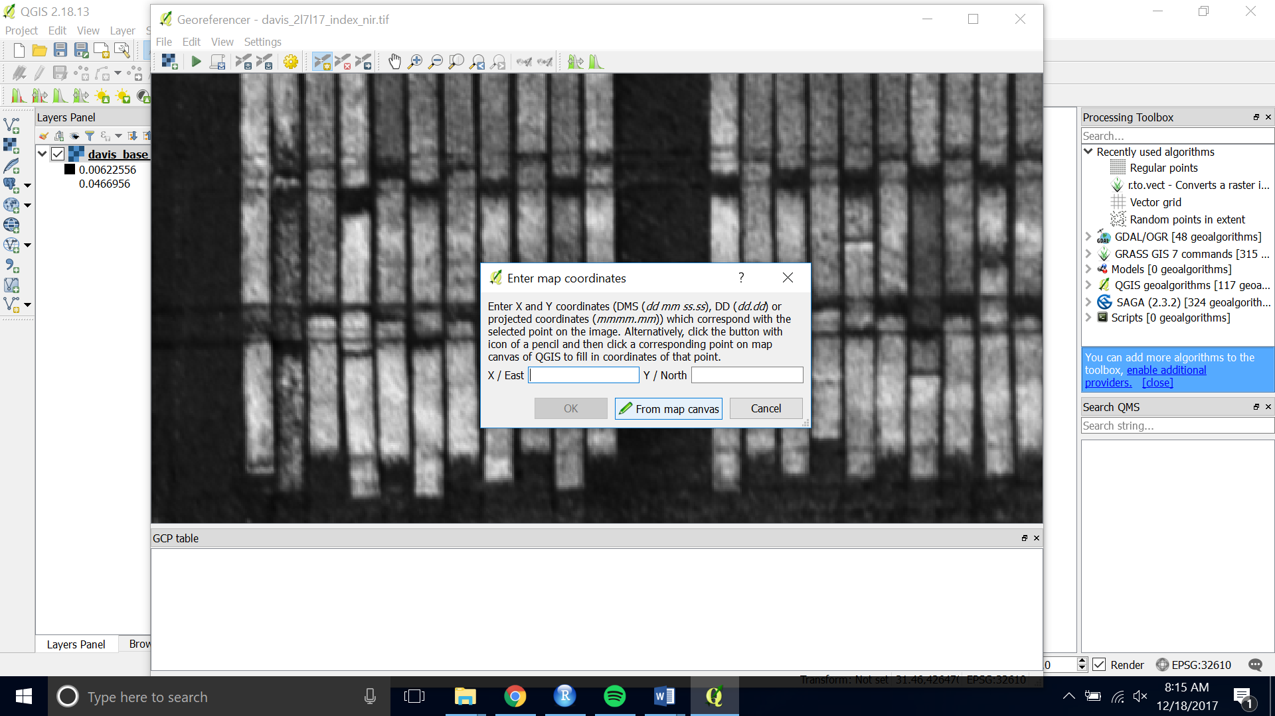

1. Pan, zoom and click on the same point on the base image you loaded onto the map canvas.
2. Then click “OK” to save the point.

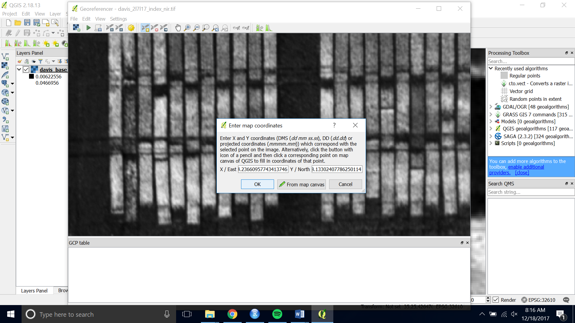

1. Do this for 5 – 10 points around your image.
2. When you are satisfied with the number of ground control points, choose “ Start Georeferncing” (the green play button)

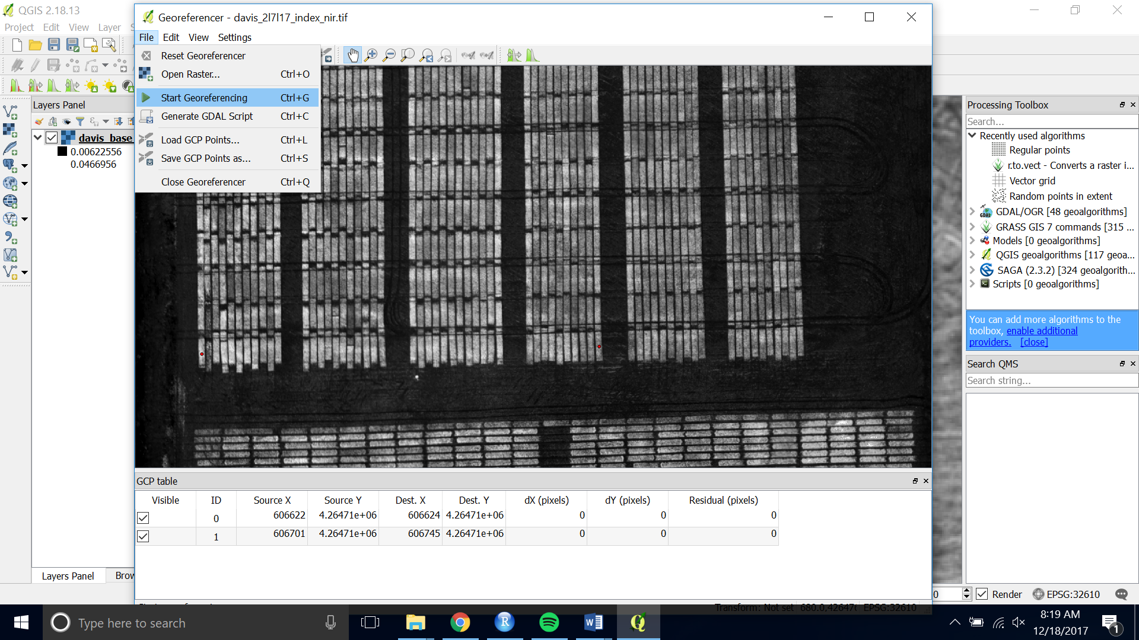

1. If asked for the transformation information you can stick with the default. Check Load in QGIS when done and set the name of your output raster.

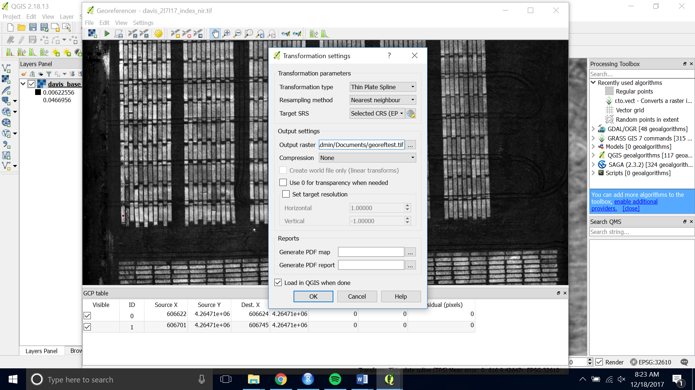

1. Press the green “Start Georeferencing” button again. The georeferenced image will be save and loaded onto the canvas.
2. You can check that it aligns with your shapefile by loading the shapefile onto of it.